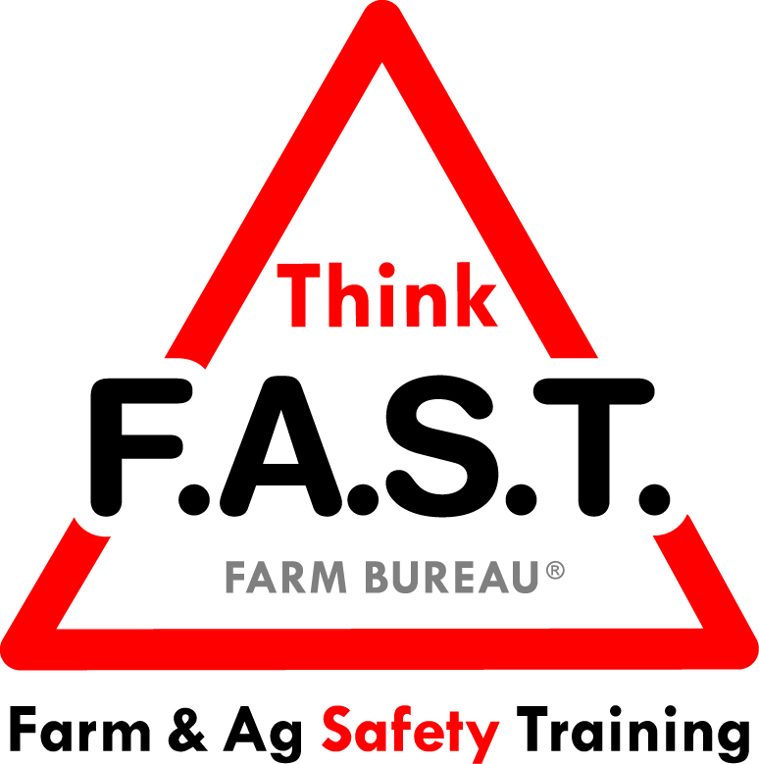

Module 2: Spatial Awareness with Livestock

Objectives:
- The learner will understand how vision, specifically spatial awareness, is a valuable asset in an agricultural environment.
- The learner will demonstrate comprehension of livestock awareness and interaction skills.

Time Required:
- Approximately 40 minutes

Materials & Set-Up:
- Pens/paper – per individual
- Regionally appropriate animal with adequate pens or area to safely demonstrate livestock concepts (Ex: horse, cow, calf, pig, sheep, etc.)
  - Optional: More than one species available
(*Note: If more than one species available for the training, a responsible adult should be with each species/group.)
- Instructor or appropriate person available to talk specifically about the livestock present

Lesson:

Introduction
- To engage youth, ask them to close their eyes for an activity. Ask them to name specific items that they saw around the teaching area prior to closing their eyes.
- After a few responses, ask them to open their eyes and continue by naming items that they missed.
- Remind them of how our surroundings – and our awareness of them – contribute to our safety.
- Preview that today’s focus is on livestock and the importance of safe handling. Note that our senses supply information for us to interact with our surroundings, and our vision is a critical component.

Suggested Skill Building Activities:
*Note: Instructor may modify for time and regionally-appropriate content, as long as safety and core skills are adequately addressed.

- Awareness All Around
  - Remind youth about the definition of spatial awareness: the ability to be aware of yourself and your actions within a space.
  - Ask them to name examples of what this looks like in real life.
    - Ex: Being able to judge the distance to your mouth when lifting a cup to drink.
  - Follow up with the following discussion questions:
    - If we lack spatial awareness, how does that affect our daily life?
    - What can happen with our spatial awareness when we experience a change in our environment?
    - What can we do to have more spatial awareness?

Core skill: We have to be aware of our surroundings and the possibilities for danger within them to stay safe
Indicators of activity success:
- Through active participation, learners are engaged in discussion.
- Learners demonstrate or vocalize appropriate responses regarding spatial awareness.

- Interacting with Livestock
  - Have youth gather around the livestock pen/area. If applicable, introduce adult guest(s) for livestock portion.
  - Remind youth that even the most trained livestock can act differently when in a new situation.
  - Ask youth questions to gauge their ability and needs regarding working with livestock, such as: “How should you approach livestock? What should you always have when working around livestock?”
  - Give brief background on livestock. For example, talk about specific temperament, aggression, herding, and health traits of the species at the training. Demonstrate point of balance and flight zone concepts with the animal.
    - If multiple species available, break class into smaller groups, and rotate through each species to talk specifics and demonstrate point of balance and flight zone.
  - Consider introducing livestock working facilities topics, such as metal pens vs. wooden pens, access points, escape points, and proper restraint mechanisms.

Core skill: Properly interacting with and handling livestock is critical to safety.
Indicators of activity success:
- Through active participation, learners demonstrate working knowledge of interactions with livestock.

- Interacting with Livestock, Continued
  - Have youth pair up. In their team, they are to think of a way to handle/interact with livestock that is either good, ok, or bad.
  - Have volunteer teams come up and act out their interaction, with one partner being the “livestock” and the other the “handler.”
  - The youth that are not performing need to “rate” the interaction with the livestock as good (thumbs up), ok (thumb in the middle), or bad (thumbs down).
  - After each team does their role play, there will be time for group discussion or teaching points from the instructor, as applicable.

Core skill: Properly interacting with and handling livestock is critical to safety.
Indicators of activity success:
- Through active participation, learners demonstrate working knowledge of interactions with livestock.

Reflection Questions
- To close out the lesson, ask youth the following questions, and allow for individual or group discussion:
  - Have you ever been in a potentially dangerous situation with livestock? How did you react? What could you have done differently?
  - What is one change you are going to make regarding your interactions around livestock after this training?

Challenge
- The next time you enter into a pen or area to work with livestock, take special note of your surroundings. Use all of your senses to become fully aware of your environment. Take a few minutes to think about your solutions for potential dangers.

Additional Resources:
- Dr. Temple Grandin, animal welfare expert: www.grandin.com

- Marshfield Clinic, North American Guidelines for Children’s Agricultural Tasks: Working with Large Animals http://www.nagcat.org/proxy/MCRF-Centers-NFMC-NAGCAT-Guidelines-PDF-A8.2.pdf

